**Tell me a secret**

## Step 1: Make it

### What is it?

Use micro:bit’s radio feature to answer questions in secret.

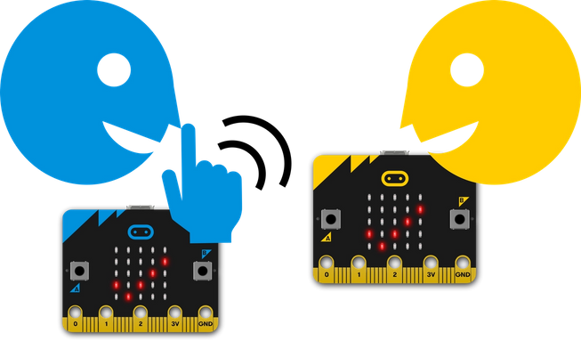

### How it works

* Flash this program on to two micro:bits. You and a friend ask each other questions that have ‘yes’ or ‘no’ as the answer.
* Press input button A to send ‘yes’ and button B to send ‘no’ messages. A tick or cross will flash on both micro:bits’ LED display outputs for half a second.
* The program uses radio to send your answer secretly - no-one (except your partner) can hear the radio signal.
* When a radio message is received, the program uses **selection** to test the message: **if** the received message **is equal to** ‘yes’, **then** it shows a tick on the LED display, but **if** the message **is equal to** ‘no’ **then** it shows a cross.
* Make sure the radio group number is the same on both micro:bits – you can use any number between 0 and 255.
* If lots of you are using this program in the same place, you’ll want to make sure each pair of people has their own radio group number.
* Keep your radio group number a secret if you don't want anyone snooping on your messages!

### What you need

* Two micro:bits (or MakeCode simulator)
* MakeCode or Python editor
* battery pack (optional)
* a friend and a secret to share!

## Step 2: Code it

